

**A Report on Electronics Prototyping**

**LED lamp from wooden blocks**

Submitted by,

**Mehul Patil (Scsb305)**

**Niranjan Patil (Scsb307)**

**Abhishek Sarraf (Scsb320)**

|  |  |  |  |
| --- | --- | --- | --- |
|  | **Course:** | **Prototyping** |  |
|  | **Course code:** | **ET206** |  |
|  | **Module:** | **Electronic Prototyping** |  |
|  | **Block:** | **B3** |  |
|  | **Branch:** | **Electronics Engineering** |  |
|  | **Batch:** | **B1** |  |
|  | **Dates:** | **31 st August- 11th September 2017** |  |
|  | | | |
|  | | | |
| **Alandi (D), Pune =412105** | | | |
|  | | | |
| **Year 2017-18** | | | |

|  |  |  |
| --- | --- | --- |
| **Examiner-1** | Name: | Sign and Date: |
| **Examiner-2** | Name: | Sign and Date: |

Contents

|  |  |  |
| --- | --- | --- |
| **1** | **Abstract** | **03** |
| **2** | **Introduction** | **04** |
| **3** | **Motivation** | **05** |
| **4** | **Concept** | **06** |
| **5** | **Product Survey** | **07** |
| **6** | **Circuit Diagram** | **08** |
| **7** | **Operation** | **09** |
| **8** | **PCB Design (Topside/Bottom side)** | **10** |
| **9** | **Product Assembly photos** | **12** |
| **10** | **Final Product Photographs** | **13** |
| **11** | **Product Specifications** | **14** |
| **12** | **Cost Analysis** | **15** |
| **13** | **Targeted Customers** | **16** |
| **14** | **Conclusion and Future scope** | **17** |
| **15** | **References** | **18** |
| **16** | **Annexure-1 Bill of Material** | **19** |
| **17** | **Annexure-2 User’s Manual** | **20** |

Abstract

People now days prefer to lighten up their homes with lamps that serve two purposes, one, of providing light and second of making the room look more fashionable and artistic not just this but it should also be able to save energy so that the power consumed is less.

Our product, LED Light, does both with perfection. It adds that extra spark to the room which catches every person’s eye.

Led Light is a product designed with great precision to maintain the balance between too bright and too dark. It has a beautiful and cost effective design that is enclosed in a wooden and glass framework. The decorations such as the grass pallet and the MITAOE logo on the top makes it a true eye catcher.

Its perfection is what makes it a must buy.

Introduction

Those days are long gone where people used to buy stuff that got the job done, irrespective of its appearance.

Today, we want a commodity that’ll not only get the job done, but that also is appealing to the eye.

So, we’ve designed a lamp that will fulfil this need of our every customer and will also keep their monthly budget in mind by saving electricity without having to compromise with quality.

Motivation

We’ve been to several places where the lamp is either too bright or too dark or it just doesn’t fit with the surroundings. That just spoils the ambience and feel of the room and also it generates huge amount of electricity bill per month. After observing, even more, we came to realise that such lamps consume a lot load of energy than they actually should.

It was this that motivated us to build a lamp that solves all these issues.

Concept

**What’s LED Light all about?**

Led Light is a product that is an all-purpose lamp. It can be used as a night lamp; it can be used in any party/function. It’s dark but sufficient amount of light makes the atmosphere more pleasant and in some cases, more romantic :) Its 12v SMD LED covered by wood and glass framework emits enough light to create an eye catching effect. Also the decorations on it make it a real eye catcher. The product is designed to consume as little electricity as possible without compromising with the quality and quantity of usage.

Product Survey

We’ve seen that lamps of many varieties are available in the market. But the lamp our team is offering is special one. It uses less power than most of the lamps present there. Also, the amount of light is emits is unmatched in its power bracket. Its sleek looks are its main characteristic. The lamp is beautifully engineered to perfection giving it a finishing touch. The glass addition makes it a real eye catcher. The led technology used helps to save power hence the electricity bill generated is comparatively low as compared to other lamps without compromising with the quality of usage.

Circuit Diagram

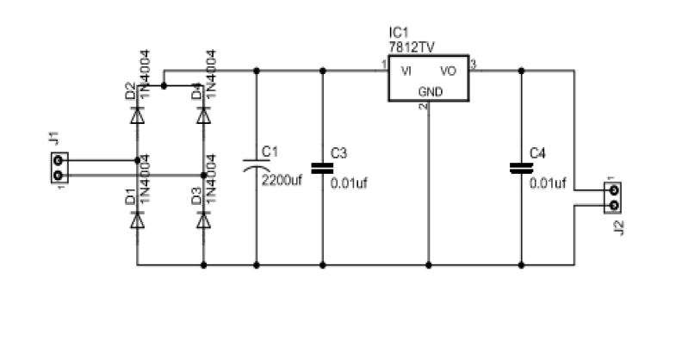

Figure 1

Operation

LED Light consists of different electronic components which help it function in the desired way.

The components are placed on a PCB.

The power supply consists of regulator (7812), capacitors (220mf and 0.1mf, 25v) and diodes (1N4007)

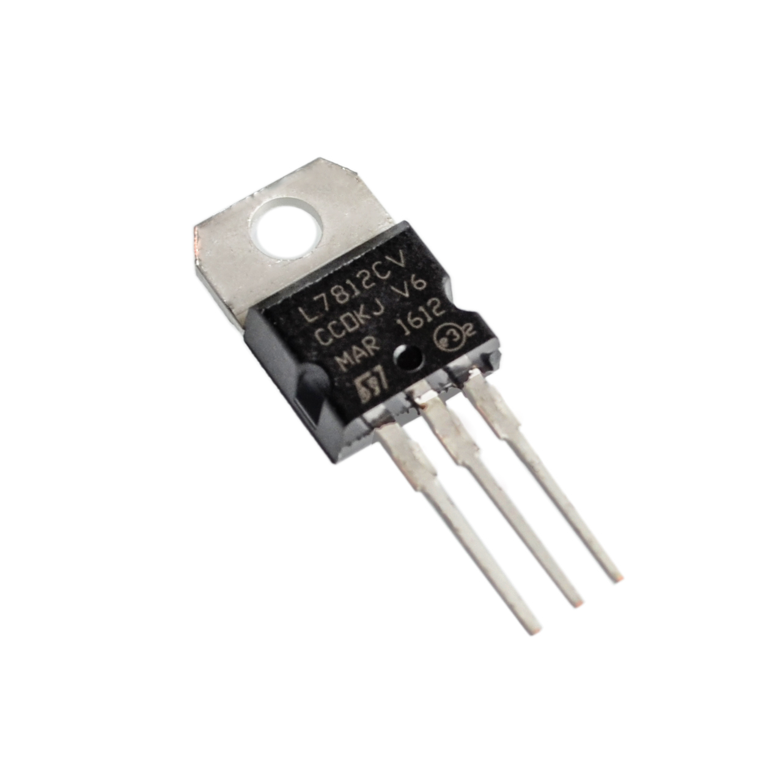

**Regulator IC 7812: -** A regulator is used to maintain a constant voltage level of 12v. Its current output is 1A and voltage is differs from 5-24v. It also protects from thermal overloading and short circuits.

**Capacitors: -** A capacitor is a passive two-terminal electrical component that stores electrical energy in an electric field. The effect of a capacitor is known as capacitance. While capacitance exists between any two electrical conductors of a circuit in sufficiently close proximity, a capacitor is specifically designed to provide and enhance this effect for a variety of practical applications by consideration of size, shape, and positioning of closely spaced conductors, and the intervening dielectric material.

**Diodes: -** A diode is a two-terminal electronic component that conducts primarily in one direction (asymmetric conductance); it has low (ideally zero) resistance to the current in one direction, and high (ideally infinite) resistance in the other.

PCB Design

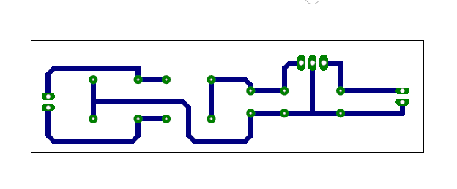

Figure 2

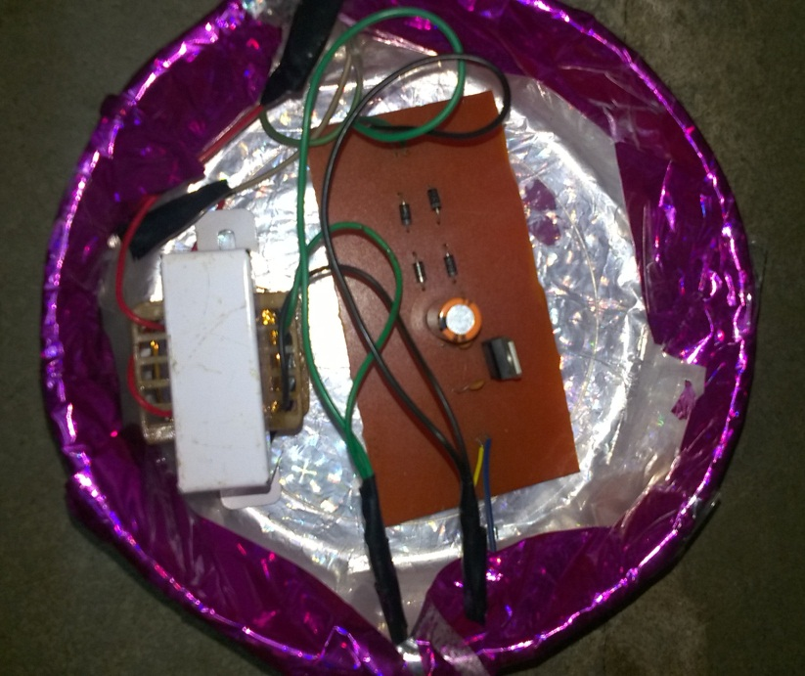

Product Assembly Photos

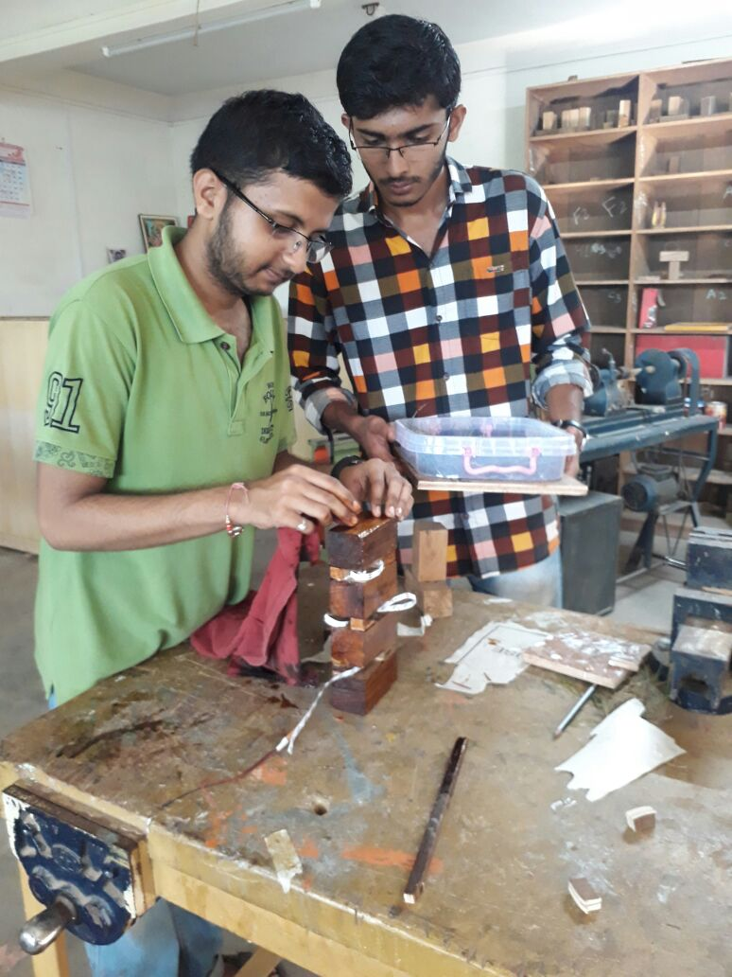

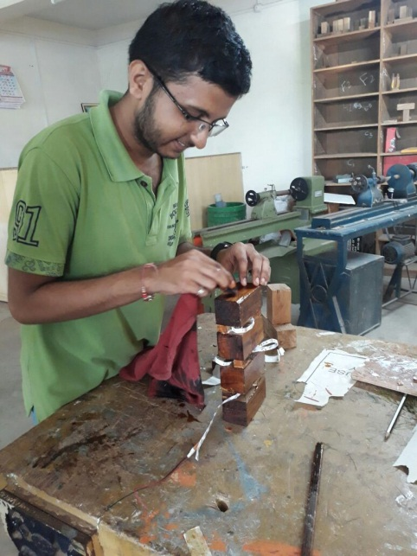

Final Product Photographs:

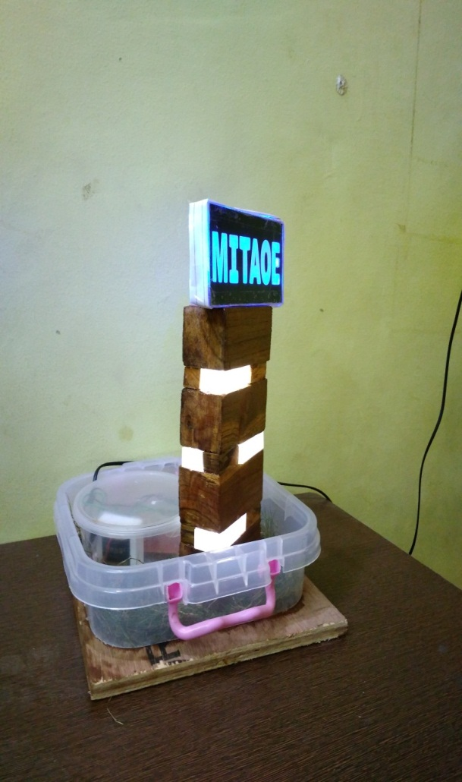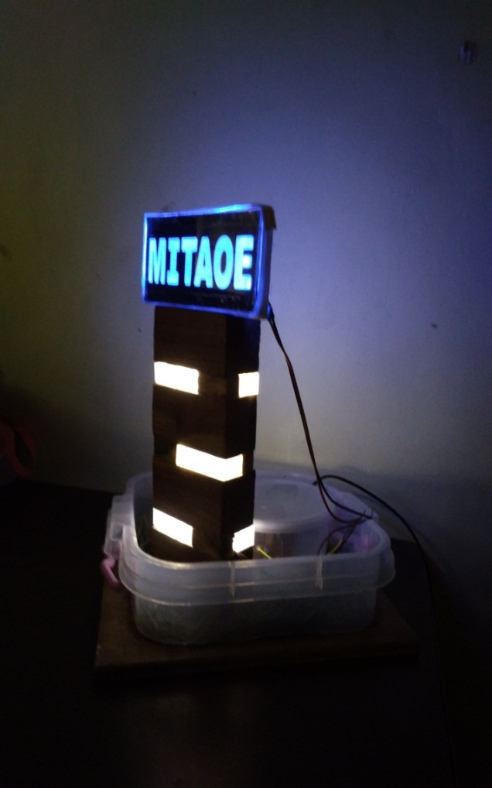

Product Specifications

**Product name: - LED lamp From Wooden Blocks**

**Sales Package: - One wooden lamp**

**Size : - Medium**

**Function : - To emit light when switched on**

**Material : - Durable wood and gl**

**Input Voltage: - 230v AC**

**Output Voltage: - 12v DC**

**Maximum Current:- 1A**

**Switch : - No**

Cost Analysis

The more the production the cheaper gets the cost.

The entire component in our prototype were bought at a retail store with retail price with some reduction in cost and turned out to be around Rs 510. If the same components were manufactured by the company itself at that time the manufacturing of the product will go down to Rs350-400 approximately. So we can analyse the situation that if this product is manufactured by a company and then sold at a retail price of Rs 650-700, there will be a huge profit margin of more than 233-315% which is a good profit line.

Targeted Audience

Our target audience isn’t restricted to any category. Everyone in the home needs light. So, everyone does buy lamp/bulbs. Our product fits in that category.

Also, people who generally have parties at the home will also prefer it as it adds that extra spark to the room. So, our product’s target audience is people of the lower middle class and above.

It includes everyone, students, teachers, doctors, lawyers, everyone.

**1**

Conclusion and Future Scope

**Conclusion: -** After successfully creating the in PCB in the first attempt and doing the connections appropriately, LED Light is now a working prototype.

**Future Scope:-**

* We can make use of a more durable cardboard that will make the lamp tougher.
* Multicolour LEDs can be used to increase the show of the lamp.

References:

1. <https://youtu.be/2Suhlltm_-w>

2. <https://www.youtube.com/watch?v=yPiidwksnhs>

3. <https://www.youtube.com/watch?v=M-k7QGaKEM8>

Annexure-1

Bill of Material

|  |  |  |  |  |  |
| --- | --- | --- | --- | --- | --- |
| **No** | **Item** | **Manufacturer** | **Quantity** | **Rate** | **Cost** |
| 1 | Transformer | Local | 1 | 180 | 180 |
| 2 | LED Strip | Local | 2 | 50 | 100 |
| 3 | AC Cord | Local | 1 | 50 | 50 |
| 4. | Wires1 | Local |  |  |  |
| 5. | Copper Clad | Local | 1 | 35 | 35 |
| 6. | Capacitor | Local | 2 | 15 | 30 |
| 7. | 4007 Diodes | Local | 4 | 4 | 4 |
| 8. | IC7812  Regulator | Local | 1 | 20 | 20 |
| 9 | Wooden Blocks |  |  |  |  |
| 10. | Acrylic Sheet |  | 1 | 50 | 50 |
| 11.. | Fevi kwik |  | 2 | 10 | 20 |
| 12. | Fevicol |  | 1 | 10 | 10 |
| 13. | Paint |  |  |  |  |
| 14. | Photo Paper |  | 1 | 10 | 10 |
|  |  |  | Total cost | | 510 |

Annexure-2

User’s Manual

**Steps to Follow:-**

1. Turn on the switch.
2. Enjoy the ambience created by the lamp.